Exam 2 CCN

Kip Taylor

1. Consider a case in which we organize the data to be transmitted into a 2D array, such that the last row and the last column are even parity bits

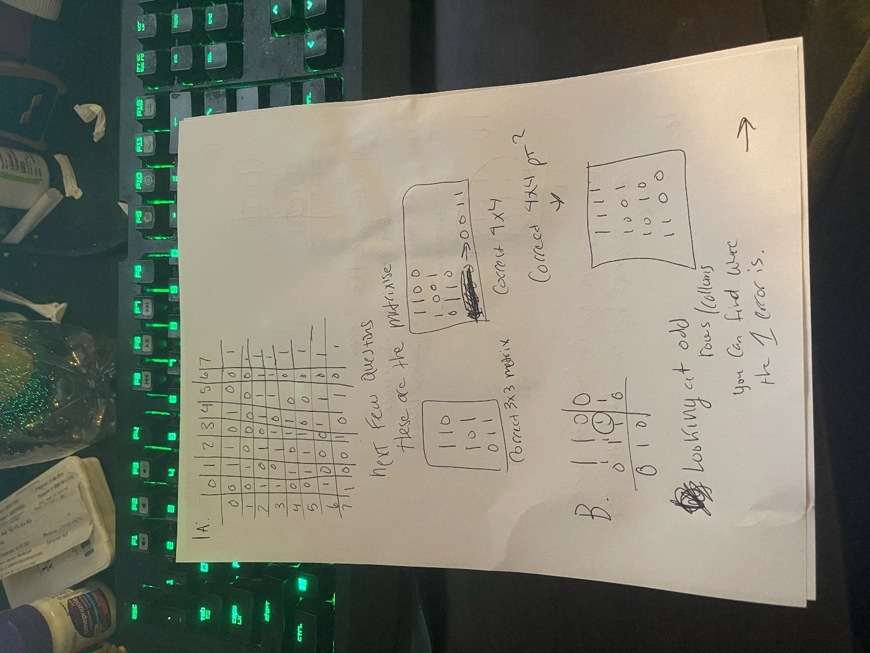

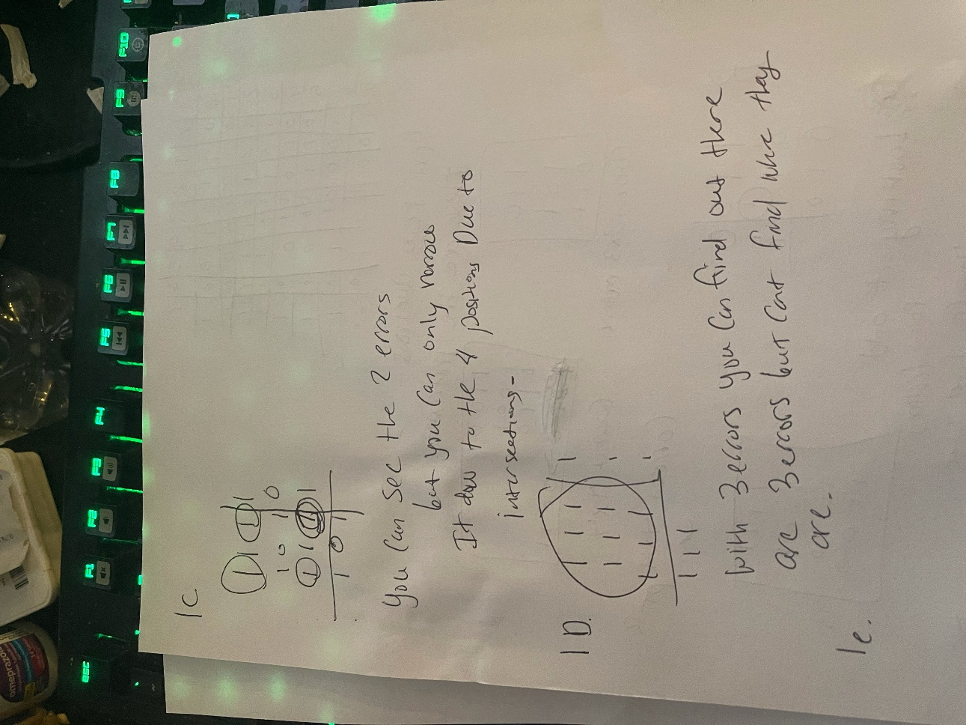

1. Below are tables for answer to e.

Ex :

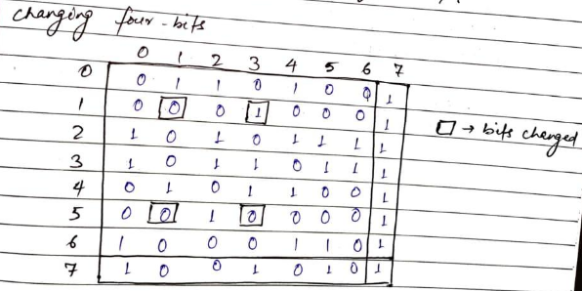 if we change those same bits, we can see the parity is the same so it won’t be able to detect an error and the message will be transmitted with the error

Ex 2 :

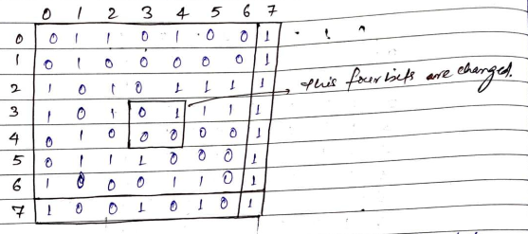

Four different ones are changed here, instead the message has a 4 bit error and thus no parity bit is changed, the message will transmit successfully without detecting error , thus we can affirm that 2d parity cannot detect some 4 bit errors.

1. We want to transmit an 11-bit message M = ←−−−−−−−−−−−−− 1 1 0 0 1 1 1 0 1 1 0 using Hamming code (read the code from right-to-left
2. Bits needed:

N = 11 bits

K = 4

2^k -1 = n +k

15 >= 15

P1 = 2^0 = 1

P2 = 2^1 =2

P4 = 2^2 = 4

P8 = 2^3 = 8

1. Answer below:

1100111P8011P40P1P0

P1 = 0 1 0 1 1 0 1 = 0

P2  = 0 1 0 1 1 1 1 = 1

P4 = 1 1 0 0 0 1 1 = 0

P8  = 1 1 1 0 0 1 1 = 1

1. **received as above ^**
2. to computer parity for P4 we must take care of 8 to 15

**0 1 1 1 0 1 1 0**  then number of odd ones implies there is an error.

P1 ( 1,3,5,7,9,11,13,15) -> 1110110 =. 0

P2 ( 2,3,6,7,10,11,14,15) -> 01001110. 0

P4 ( 2,5,6,7,12,13,14,15) -> 11000110 . 1

P8 ( 8,9,10,11,12,13,14,15) -> 01110110 =0.

1. Bit positions , calculate all parities.

There is an error at p4 – returns a 1 not a 0 , P8P4P2P1 = 410

1. It flips back the P4
2. Hammering rate : R = 1 – 4/2^4 -1

11/15 is the answer = .73

1. Answers below using formulas given above:

B = 1Mbps , Frame size = 4kb , T delay = 32.768ms , total round trip - 1024 ms

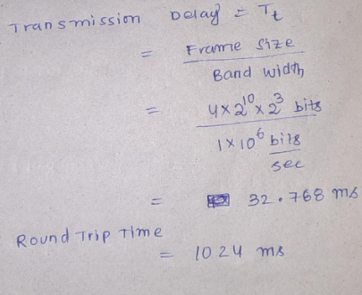

1. Stop and wait efficiency: useful time / total time = 1/ 1 + 2x 512

.032 = **30.3%**

1. Sliding window of 16 max cap :

= 1+2.tp/te = packets

1 + 2x ( 512/ 32.768)

= 32.23

Efficiency = used / total

16 / 32.25 **= 48.5%**

1. Max uti = ws = 1 + 2x tp/Tt

1 + 2x 512 / 32.768

* 1. packets/ frames

Max = 33 frames can be sent.

Window size = 33 frames

# of bits sequence

Log2 ( window size)

Log2(33) = 5

**W = 33 frames**

1. **Window size=33 frames then log base 2 (33) = 5 bits**
2. Answers below :
3. **The backoff protocol is designed to be fair for all hosts if they are all synchronized , after each collision chances of collision getting reduced , so yes.**
4. (first collision)A ------> < ------- B ( 2nd collision)

[ 0 -> 2 -1] * slot time [ 0-- > 2^2 -1] * slot time

0* slot time 🡨-----------------------🡪 0* slot time

1* slot time 🡨-----------------------🡪 1* slot time

2* slot time

3* slot time

1. **Chance of collide again = 2/8 = .25**
2. **Minimum delay A: 0* slot time**

**B: 0* slot time**

1. **Maximum delay A: 1* slot time**

**B: 3* slot time**

**Illustration is to help understand.**

1. **Answers below**
2. The nodes that are inside the range of E are {B,F}

The nodes that are outside of range of B are {F}

Thus the hidden nodes are {B,F}\bigcap **{F} = {F} because F is hidden from B and the signal from F to E will collide with signal from B to E**

**The nodes inside the range of B are { A,C,E}. then the exposed nodes are {A,C,E} – {E} = {A,C}**

1. **The nodes are inside the range of F are {E,C}**

**The nodes that are outside the range of C are {E}**

**the hidden nodes are {E,C}** \bigcap **{E] = {E} because E hidden from C and the signal from E to F will collide with signal from C to F**

**the nodes that are inside the range of C are {B,F,D} then the exposed nodes are {B,F,D} – {F} = {B,D}**

1. **Using figure below for parts C and D**

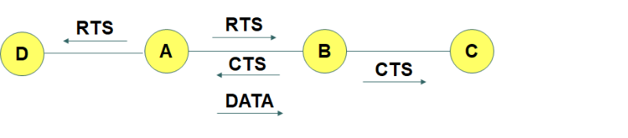

The link represents the neighbors. Here A wants to transmit to B.

1. so C is a hidden node and D is an exposed node. First, A sends RTS signal to B which is also received by D but not received by C.
2. If B is free, B will send CTS signal to A which will be received by C but not received by D. Both RTS and CTS signals contains the id of the nodes.
3. Here node C received CTS but not the corresponding RTS. So C understands that it a hidden node for transmission to B.
4. So node C keeps quiet till transmission from A to B completes even if Carrier Sense reports medium is Idle.
5. That way RTS/CTS prevent a hidden node from interfering the sender.
6. Similarly node D received RTS but not the corresponding CTS. So D understands that it an exposed node for transmission to B.
7. So D will send to nodes other than B even if Carrier Sense reports medium is busy.
8. That way RTS/CTS allow exposed nodes to transmit safely to other nodes.

SO

c) example: node a is trying to communicate with node b and c is in the range of node b , but node a.

a sends a rts to b and b responds with a CTS. C( the hidden node) will only hear the CTS and know to stay quiet so it doesn’t interfere with A - B.

d) Example: node A is trying to communicate with node B. C is in the range of node A but not node B.

same situation, a sends RTS and B responds with a CTS, but this time C only hears the RTS. Since C only hears the RTS it knows that the receiver is not in its range I and its free to transmit whenever.

Hope that helps for c and D , they are both answered in the explanation above, please reach out if you are confused, thank you.

Source, all your lectures and powerpoints/slides. This is exams was as bad as the first one.